Graphic Era Hill University, Dehradun



***Mini Project Report on Electricity Billing System***

***Submitted To: Submitted By:***

***Dr. Vikrant Mr. Ashish Padiyar***

***Cse Department Sec/Roll No. : B2/18***

***Gaphic Era Hill University Univ. Roll No.: 2218510***

***(Btech CSE 4th sem)***

**ACKNOWLEDGEMENT**

I would like to express my sincere gratitude to my teachers, for their guidance and support throughout the project. Their valuable suggestions and feedback helped me to improve my work and achieve the desired results.

I would also like to thank my peers for their collaboration and teamwork. Their contributions were invaluable, and I appreciate their efforts in making this project a success.

I would like to extend my gratitude to my parents for their constant encouragement and support. Their belief in me and my abilities motivated me to work hard and complete the project successfully.

I would like to acknowledge the University/College for providing me with the necessary resources and facilities to complete the project.

**ELECTRICITY BILLING SYSTEM**

**ABSTRACT**

Electricity consumers are often faced with the problem of inaccuracy and delay in monthly billing due to some drawbacks. Thus, it is essential to have an efficient system for such purposes via electronic platform with consideration to proximity. The proposed system automates the conventional process of paying electricity bill by visiting the Electricity Board which is tiresome and time consuming. It is also designed to automate the electricity bill calculation and payment for user convenience. The system is developed with Java swings as the base programming language which can be used to develop websites, web applications and web services. The Microsoft Structured Query Language (SQL) server is also used for creating back-end database. The system would be having two logins: the administrative and user login. The administrator can view the user's account details and can add the customer's information of consuming units

of energy of the current month in their account. The Admin must feed the system with the electricity usage data into respective user’s account. The system then calculates the electricity bill for every user and updates the information into their account every month. Users can then view their electricity bill and pay before the month end.

**i**

Abstract

# TABLE OF CONTENTS

#### i

Acknowledgment Table of contents

1. Introduction

#### ii iii

* 1. Key Features 1
  2. Benefits 1
  3. Objective 1
  4. scope 1

1. Implementation
   1. Implementation of operations
   2. Implementation of SQL statements
   3. Algorithm or pseudocode of implementation
2. Discussion and Snapshots
   1. Tables
   2. Snapshots

#### Conclusion Bibliography

2

2-3

3-5

5-8

8-10

11

12

Chapter 1

# INTRODUCTION

An electricity billing system is a software application designed to automate the

process of generating electricity bills for consumers. The system aims to overcome the limitations and challenges of the traditional manual billing system, which is often laborious, prone to errors, and inadequate

#### Key Features

Automated calculation of electricity consumption and billing Generation of accurate and detailed electricity bills

Real-time tracking of electricity consumption and billing Integration with existing electricity distribution systems User-friendly interface for easy navigation and data entry

#### Benefits

Improved accuracy and efficiency in billing Reduced manual errors and disputes Enhanced customer satisfaction and loyalty

Increased revenue for electricity distribution companies

Better management and analysis of electricity consumption patterns

#### Objectives

To design and develop an electricity billing system that is efficient, accurate, and user-friendly

To automate the process of generating electricity bills and reduce manual errors

To provide real-time tracking and analysis of electricity consumption and billing

To improve customer satisfaction and loyalty by providing accurate and detailed billing information

#### Scope

The system will be designed to cater to the needs of electricity distribution companies and their customers

The system will be developed using Microsoft Visual Basic 6.0 and MS-Access 2000

The system will be tested and validated to ensure accuracy and reliability

CHAPTER 2

## IMPLIMENTATION

### Implementation of operations

❖ **Adding Customer:** Here admin can add new customer to the customer list who started using electricity bill system.

❖ **Searching Deposit Details:** Here admin can search according to meter number and month to view deposit details.

❖ **Viewing Details**: Here admin and user can view customer details and about details.

❖ **Adding Tax:** Here admin can add tax details.

❖ **Updating Customer:** Here customer can update his/her details by using meter_no of the customer.

❖ **Delete Customer:** Here admin can delete details based on meter number.

### Implementation of SQL statements

##### Insert statement:

The INSERT INTO statement is used to insert new records in a table.

The INSERT INTO syntax would be as follows: INSERT INTO table_name VALUES (value1, value2, value3, ...).

The following SQL statement insert's a new record in the “customer” table: Insert into customer VALUES (“sai”,”12345”,” btm”,” Bangalore”, “Karnataka”, “[sai@gmail.com”](mailto:sai@gmail.com), “9876543333”).

##### Update statement:

An SQL UPDATE statement changes the data of one or more records in a table. Either all the rows can be updated, or a subset may be chosen using a condition.

The UPDATE syntax would be as follows: UPDATE table_name SET column_name =value, column_name=value... [WHERE condition].

The following SQL statement update's a new record in the “customer” table: UPDATE TABLE customer SET email= [su@gmail.com](mailto:su@gmail.com) WHERE meter_no

=”12345”.

##### Delete statement:

The DELETE statement is used to delete existing records in a table.

The DELETE syntax would be as follows: DELETE FROM table_nameWHERE condition.

The following SQL statement delete's a record in the “customer” table: delete from customer where meter_no=12345.

##### Create statement:

The CREATE TABLE Statement is used to create tables to store data. Integrity Constraints like primary key, unique key, foreign key can be defined for the columns while creating the table.

The syntax would be as follows: CREATETABLE table_name (column1datatype, column2datatype, column3 datatype, columnN datatype, PRIMARY KEY (one or more columns)).

* The following SQL statement creates a table “customer” table: create table customer (name varchar (30), meter_no varchar (20) primary key, address varchar (50), city varchar (20), state varchar (30), email varchar (30), phone varchar (30));
* The following SQL statement creates a table “login” table: create table login (meter_no varchar (30), username varchar (30), password varchar (30), user varchar (30), question varchar (40), answer varchar (30));
* The following SQL statement creates a table “tax” table: create table tax (cost_per_unit int (20) primary key, meter_rent int (20), service_charge int (20), service_tax int (20), swacch_bharat_cess int (20), gst int (20));
* The following SQL statement creates a table “bill” table: create table bill (meter_no varchar (20), foreign key(meter_no) references customer(meter_no) on delete cascade, month varchar (20), units int (20), total_bill int (20), status varchar (40));
* The following SQL statement creates a table “meter_info” table: create table meter_info (meter_no varchar (30), foreign key(meter_no) references customer(meter_no) on delete cascade, meter_location varchar (10), meter_type varchar (15), phase_code int (5), bill_type

varchar (10), days int (5));

### Algorithm or pseudocode of implementation

##### Explanation of Algorithm or pseudocode of system:

* + - Start system
    - Enter login name and password
    - On clicking the login button
    - Connect to database
    - Query database to know whether user credentials are correct

➢ If not, deny access and return login page with an error message

➢ If correct, check if credentials for administrator

➢ If yes, allow login

* + - Set admin session, re-direct administrator to admin login page

➢ If no, allow login set user session

* + - Re-direct user to user home page

##### Algorithm or pseudocode of admin:

**Login:**

* + - This program will allow the admin to enter the username and password.

➢ If the entered credentials are correct, then the login will be successful otherwise need to be signup.

➢ If admin forgets password, it can be retrieved by giving username and answer for security question.

* + - After successful login the admin will be redirected to admin portal page where he/she can do following activities.

##### NewCustomer:

* + - This program will allow the admin to enter the customer details and automatically generates unique meter number.

➢ If customer name, address, city, state, email and phone number is entered, insert the values into customer

else print error while next=true

enter the meter_info details else print meter_info error

Submit the details of customer that has been entered by clicking onto next button.

➢ If we need to cancel the particulars that has been entered click onto cancel option.

➢ If we need to submit the particulars that has been entered click onto submit option.

##### CustomerDetails:

* + - This program will allow the admin to view customer details.

➢ If we need to print the particulars that has been viewed click onto print option.

##### DepositDetails:

* + - This program will allow the admin to view bill details. If we need to sort the particulars based on meter_no and month.

➢ If we need to search the particulars that has been viewed click onto search option.

➢ If we need to print the particulars that has been viewed click onto print option.

##### TaxDetails:

* + - This program will allow the admin to add tax details. insert the values into tax

else print error

Submit the details of tax that has been entered by clicking onto submit button.

➢ If we need to cancel the particulars that has been entered click onto cancel option.

##### CalculateBill:

* + - This program will allow the admin to calculate total_bill when units consumed are inserted where meter_no and month is selected.

insert the values into bill else print error

Submit the details of tax that has been entered by clicking onto submit button.

➢ If we need to cancel the particulars that has been entered click onto cancel option.

##### DeleteBill:

* + - This Program will allow the admin to delete the customer info when meter_no is selected.

➢ If we need to delete the particulars that has been saved click onto delete option.

➢ If we need to cancel the particulars that has been entered click onto back option.

##### About:

* + - This program will allow the admin to view details of the project in short.

➢ If we need to exit the particulars that has been viewed click onto exit option.

##### Algorithm or pseudocode of Customer:

**Login:**

* + - This program will allow the customer to enter the username and password. If the entered credentials are correct, then the login will be successful otherwise need to be signup with the meter_no which is given by admin.

➢ If customer forgets password, it can be retrieved by giving username and answer for security question. After successful login the customer will be redirected to customer portal page where he/she can do following activities.

##### UpdateInfo1:

* + - This program will allow the customer to update the customer details. If customer address, city, state, email and phone number is updated,

update the values into customer else print error

update the details of customer that has been updated by clicking onto update button.

➢ If we need to cancel the particulars that has been updated, click onto back option.

##### ViewInfo:

* + - This program will allow the customer to view his/her own details.

➢ If we need to go back from the particulars that has been viewed click onto back option.

##### PayBill:

* + - This program will allow the customer to view bill details and redirects to pay
    - the bill where status will be updated.

➢ If we need to cancel the particulars that has been viewed click onto back option.

➢ If we need to pay the bill amount that has been viewed click onto pay option.

##### BillDetails:

* + - This program will allow the customer to view bill details.

➢ If we need to print the particulars that has been viewed click onto print option.

##### GenerateBill:

* + - This program will allow the customer to generate bill when meter_no and month is selected.
    - Generate the details by clicking on generatebill button.

##### About:

* + - This program will allow the customer to view details of the project in short.

➢ If we need to exit the particulars that has been viewed click onto exit option.

NOTE: Utility (notepad, browser, calculator),query and logout is given to both customer and admin portals.

CHAPTER 3

## DISCUSSION AND SNAPSHOTS

* 1. TABLES:

The given below table is a snapshot of backend view of the localhost and the structures of the tables present in Electricity Billing System. The tables present are login, customer, tax, bill, meter_info.

* + - The login is used to store the details of login’s admin and customer with meter_no.
    - The customer is used to store details of customer.
    - The tax is used to store tax values.
    - The rent is used to store rent values.
    - The bill is used to store details of bill of meter.
    - The meter_info is used to store information of meter placed.

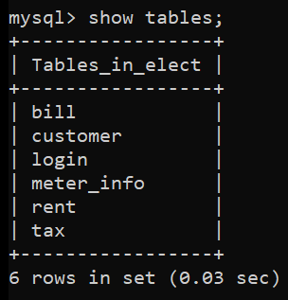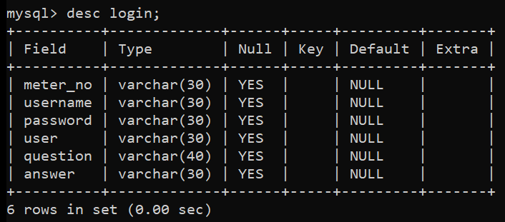

##### Login Table:

FIG 3.1:List of tables

FIG 3.2:login table description

**Customer Table:**

**Tax Table:**

**Rent Table:**

**Bill Table:**

FIG 3.3: customer table description

FIG 3.4: tax table description

FIG 3.5: rent table description

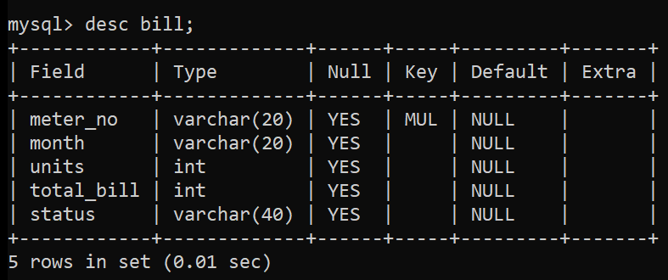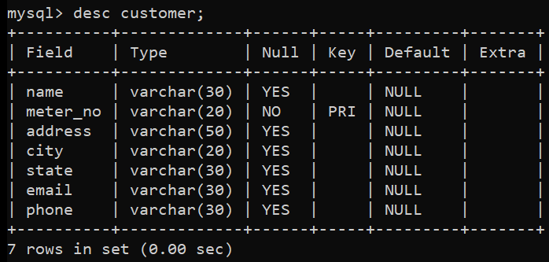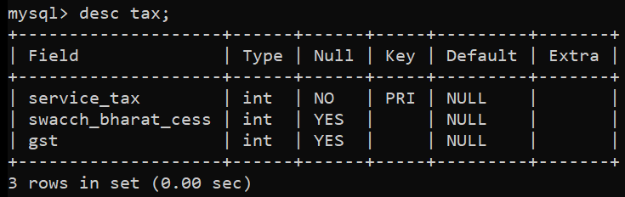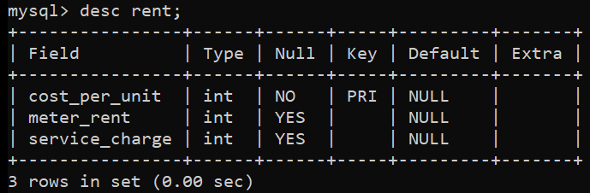

FIG 3.6: bill table description

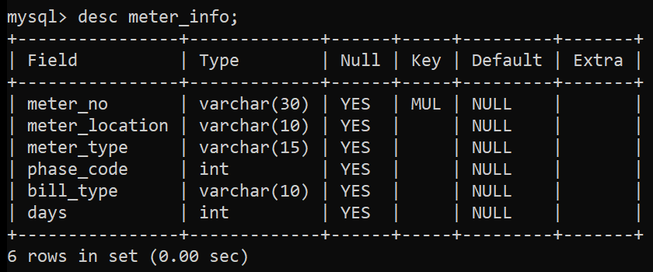

##### Meter_Info Table:

FIG 3.7: meter_info table description

* 1. SNAPSHOTS:

FIG 3.8: Splash page of Electricity Billing System

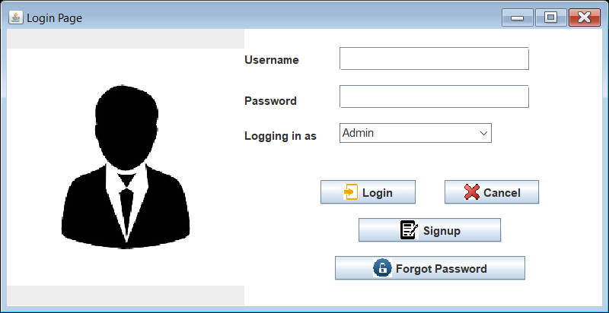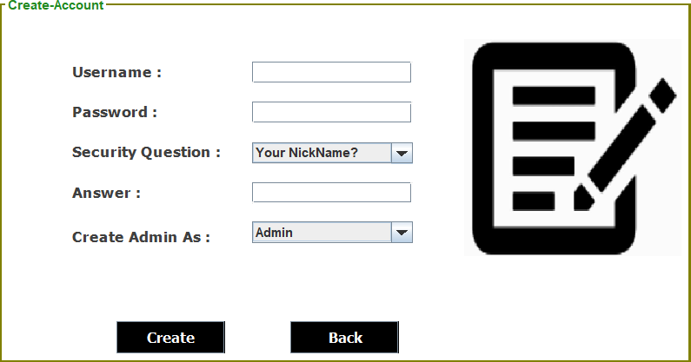

FIG 3.9: Login page

FIG 3.10: Signup page

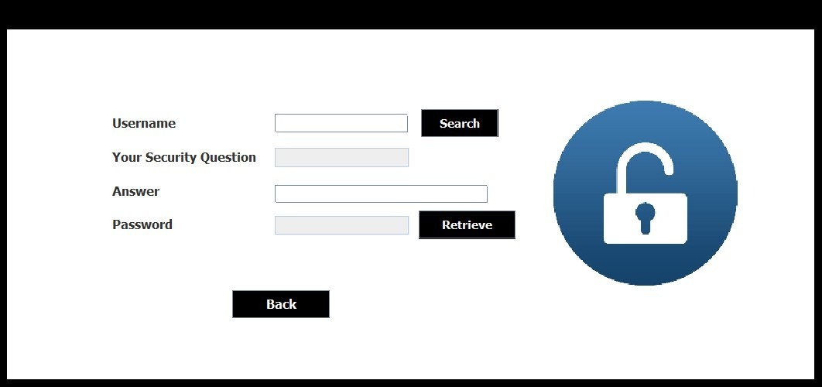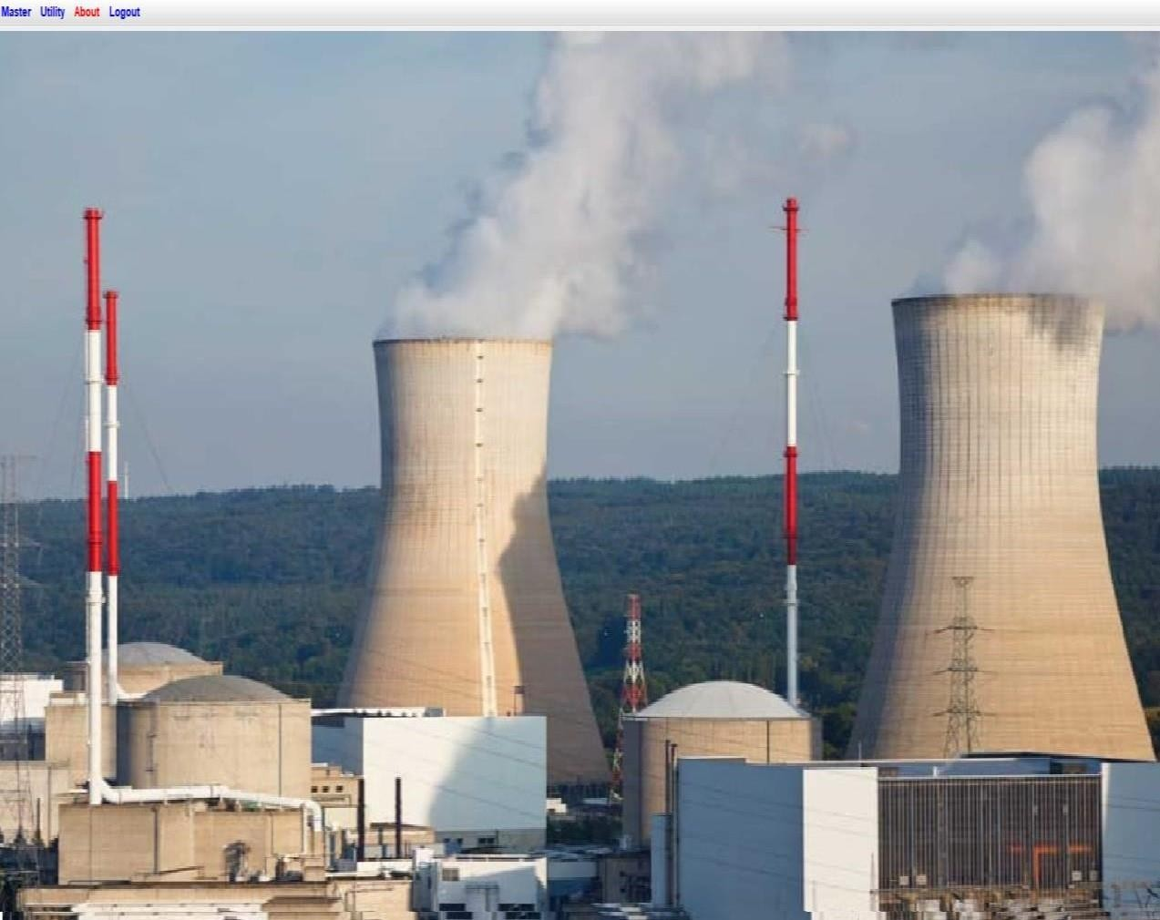

FIG 3.11: ForgotPassword page

FIG 3.12: Admin home page

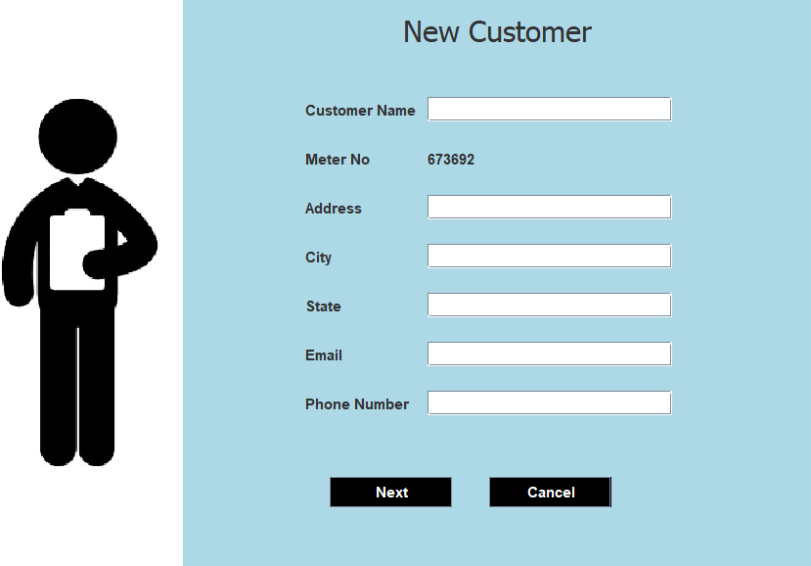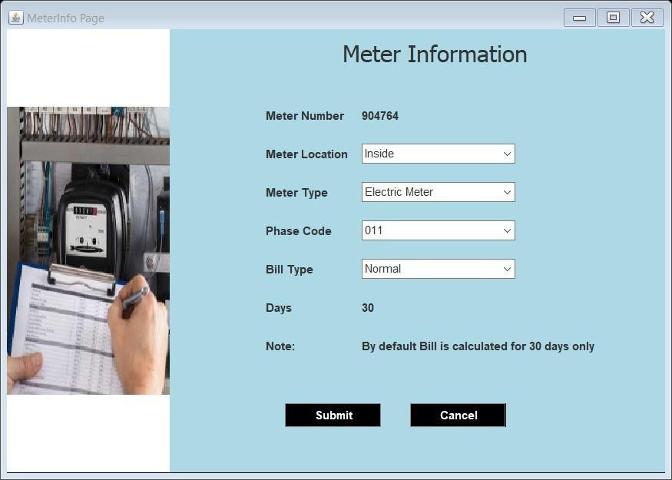

FIG 3.13: New customer page

FIG 3.14: Meter Info page

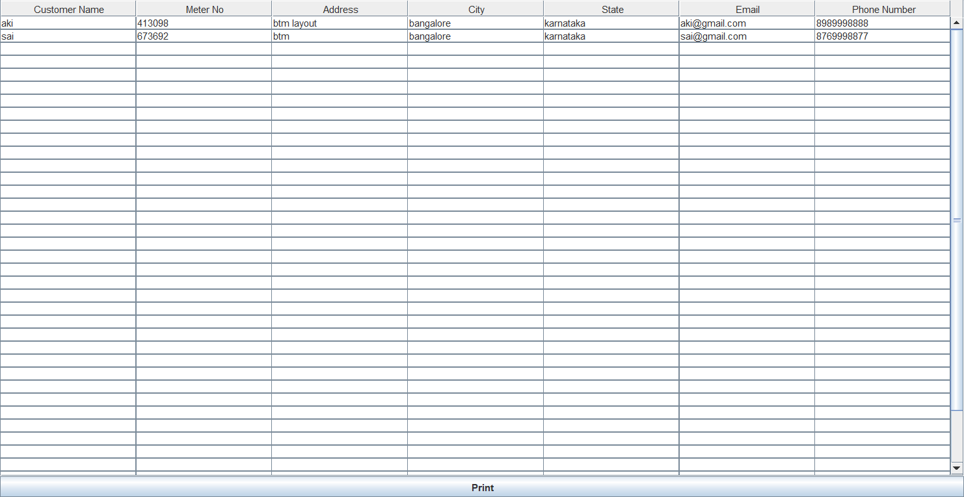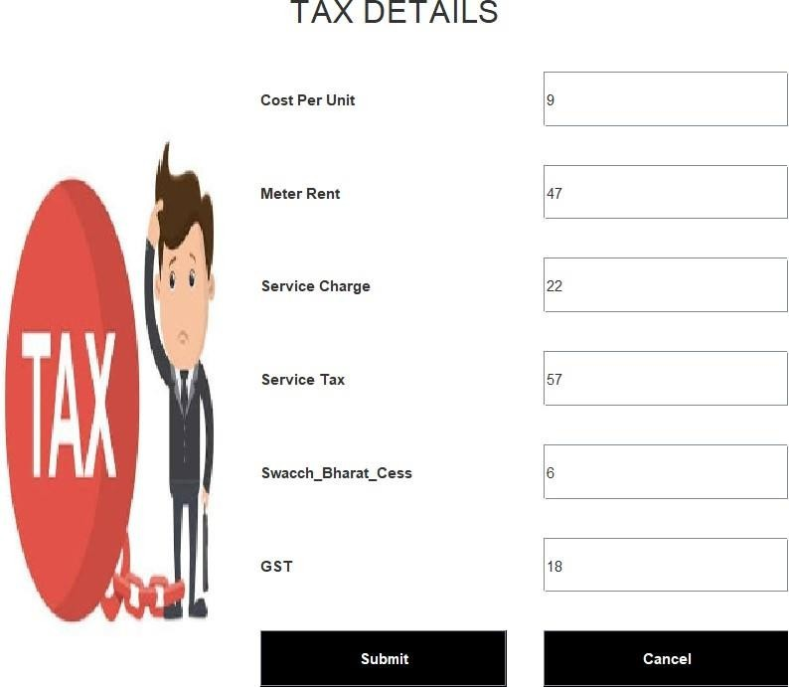

FIG 3.15: Customer Details page

FIG 3.16: Tax Details page

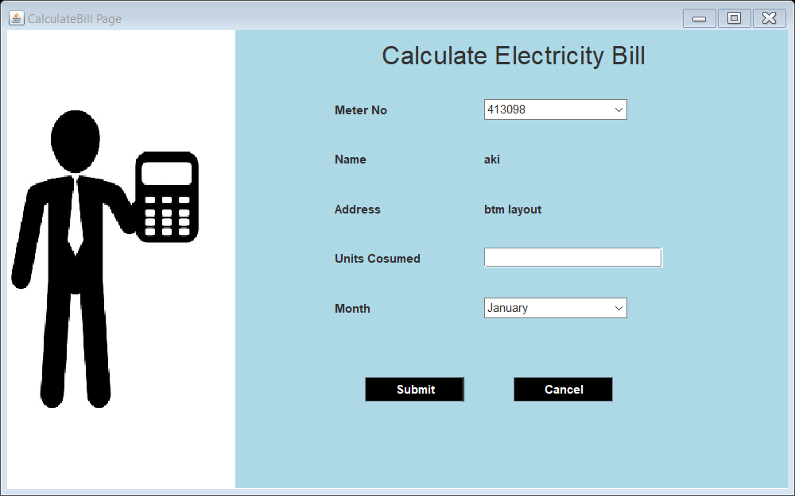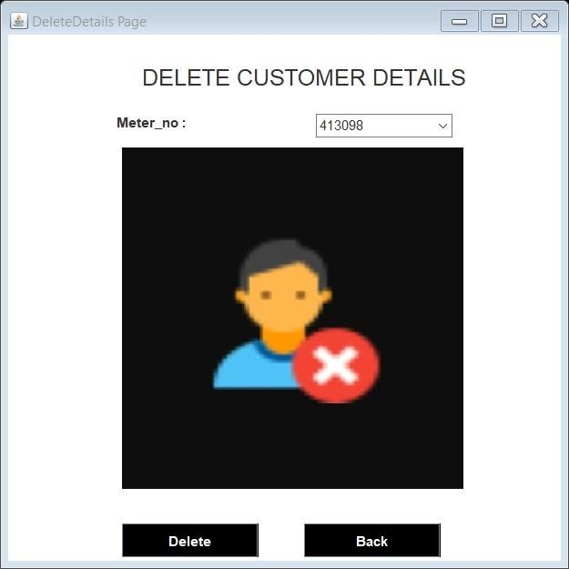

FIG 3.17: Calculate Bill page

FIG 3.18: Delete Customer page

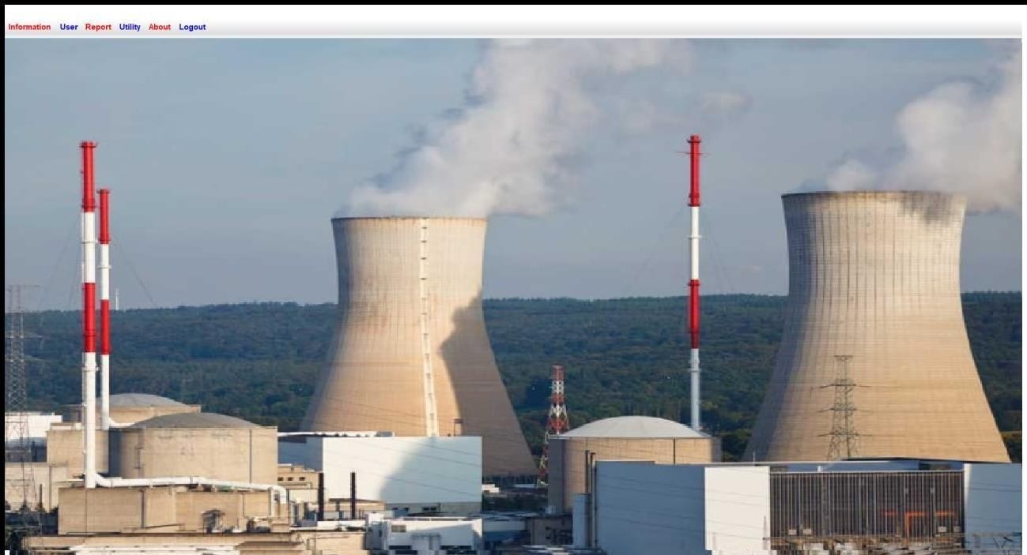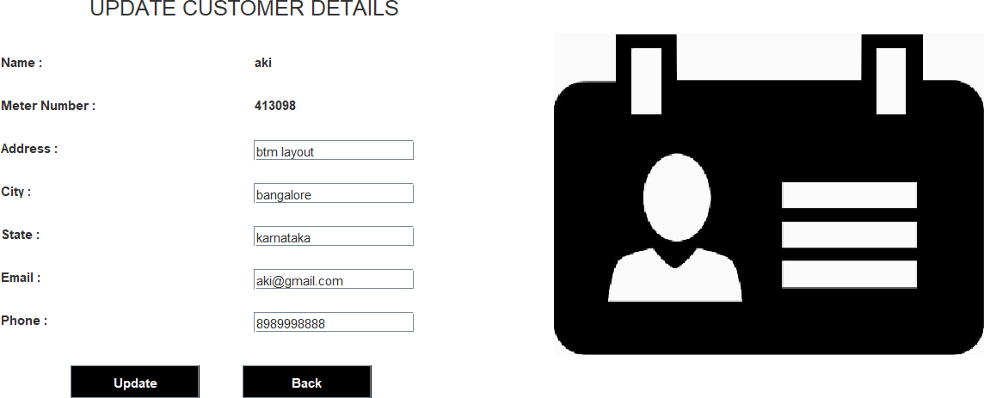

FIG 3.19: Customer Home page

FIG 3.20: Update customer details page

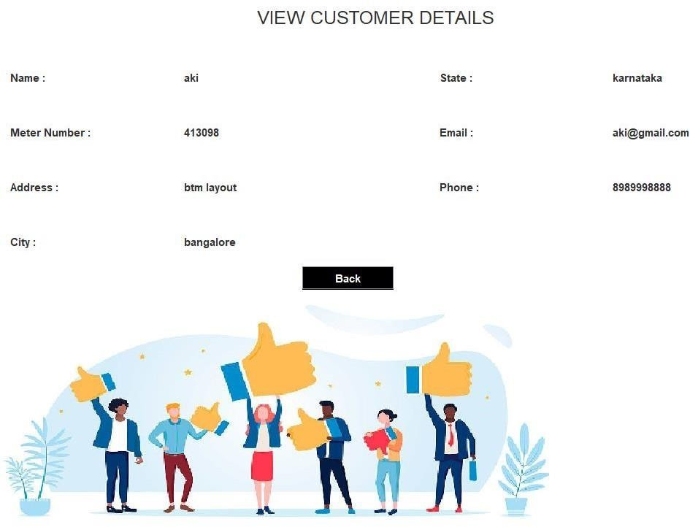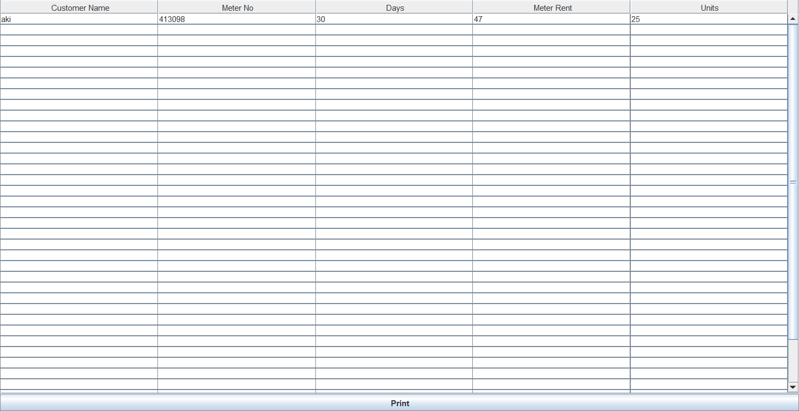

FIG 3.21: View Customer Details page

FIG 3.22: Query page

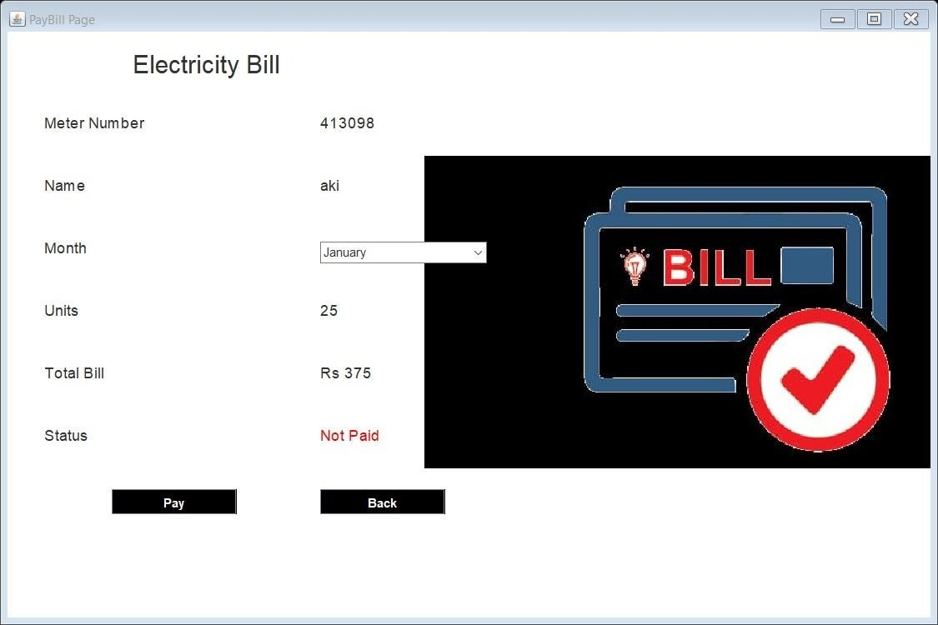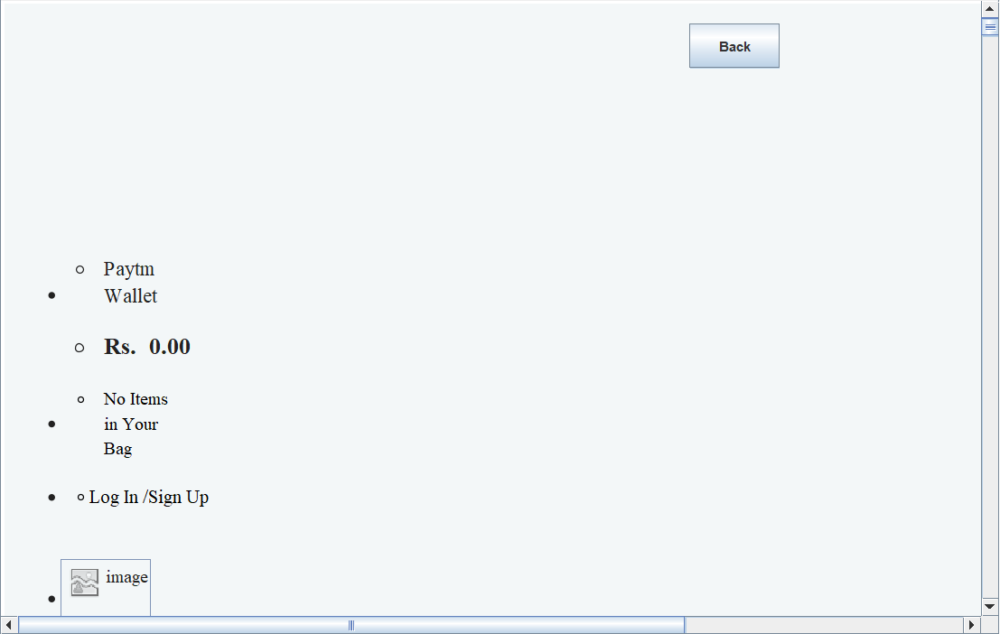

FIG 3.23: Pay Bill page

FIG 3.24: Paytm page

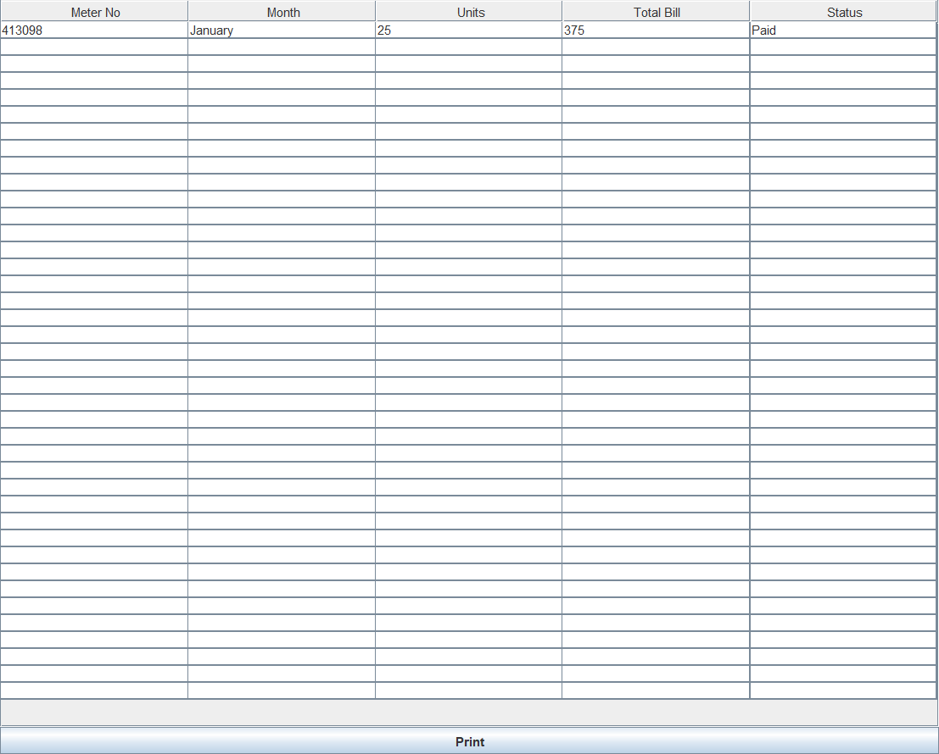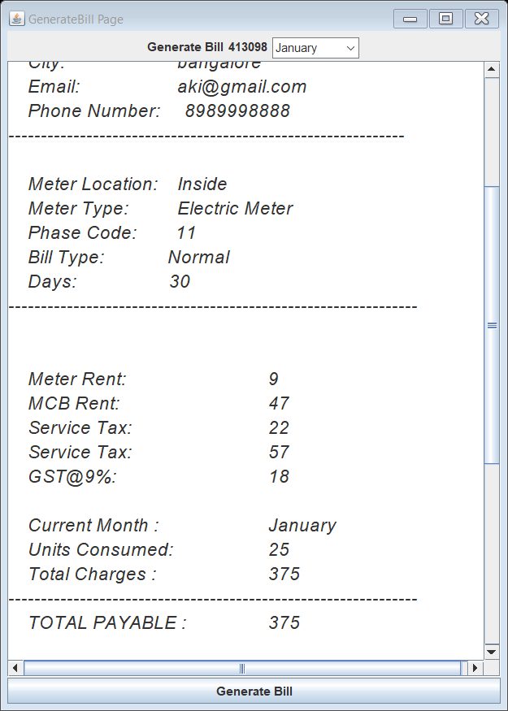

FIG 3.25: Bill Details page

FIG 3.26: Generate Bill page

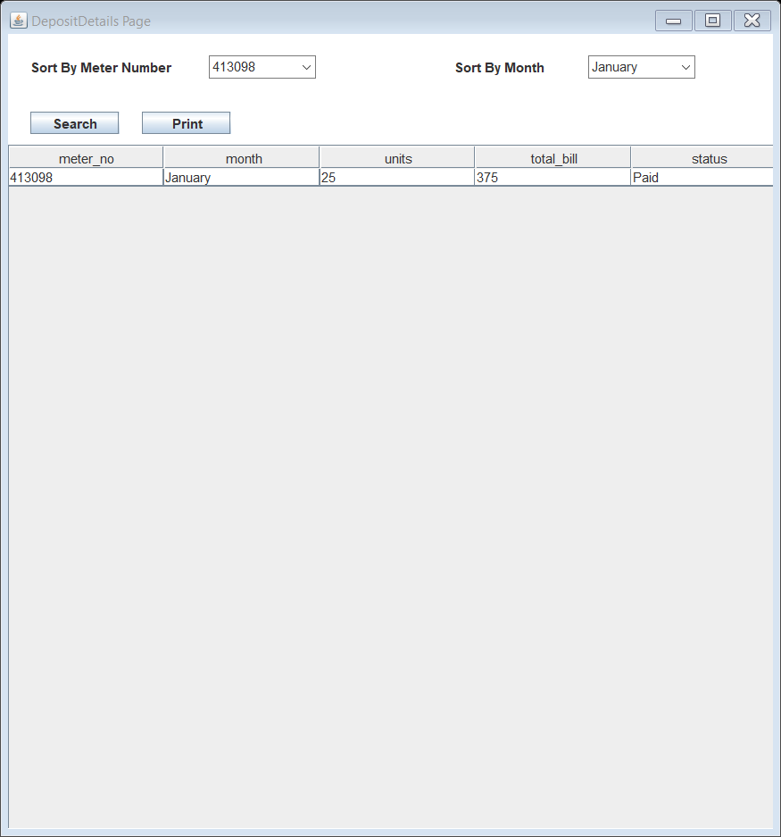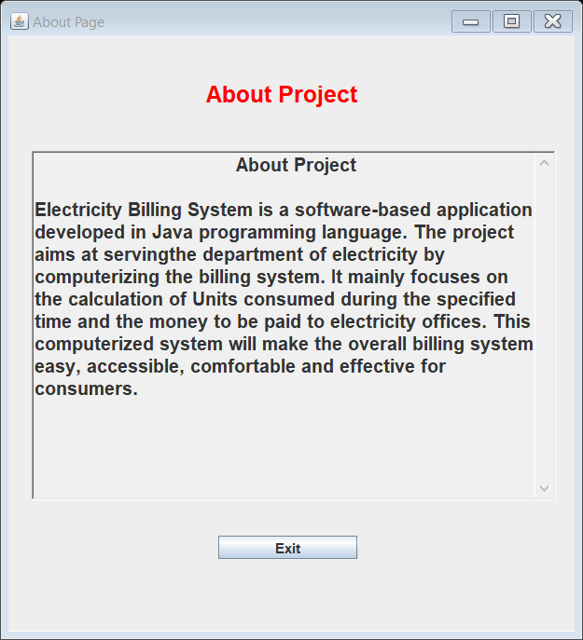

FIG 3.27: Deposit Details page

FIG 3.28: About page

## CONCLUSION

After all the hard work is done for electricity bill management system is here.

It is a software which helps the user to work with the billing cycles, paying bills, managing different DETAILS under which are working etc.

This software reduces the amount of manual data entry and gives greater efficiency. The User Interface of it is very friendly and can be easily used by anyone.

It also decreases the amount of time taken to write details and other modules.

## BIBLIOGRAPHY

**REFERENCES**

##### Book Reference

Database Management Systems 3rd Edition by Raghu Ramakrishnan (TEXTBOOK).

##### Websites

* [http://www.github.com](http://www.github.com/)
* https://[www.youtube.com/watch?v=iWitVuW2D1o&t=4s](http://www.youtube.com/watch?v=iWitVuW2D1o&t=4s)
* [www.stackoverflow.com](http://www.stackoverflow.com/)
* [www.google.com](http://www.google.com/)
* <http://www.javatpoint.com/>